# STUCOR Application - Extended Defect Report

**Defect ID :**  BUG-STUCOR-001

**Title :** Internal marks not showing for all subjects

**Description :**  Only partial subject marks are shown for

some Students.

**Steps to Reproduce :** Login → Internal Marks tab

**Expected Result :** All subject marks displayed

**Actual Result :** 2 subjects missing

**Severity :** High

**Priority :** High

**Reported By :** Varalakshmi

**Date Reported :** 18-July-2025

**Status :** Open

**Proof (Defect Location) :** Internal Marks → Subject list

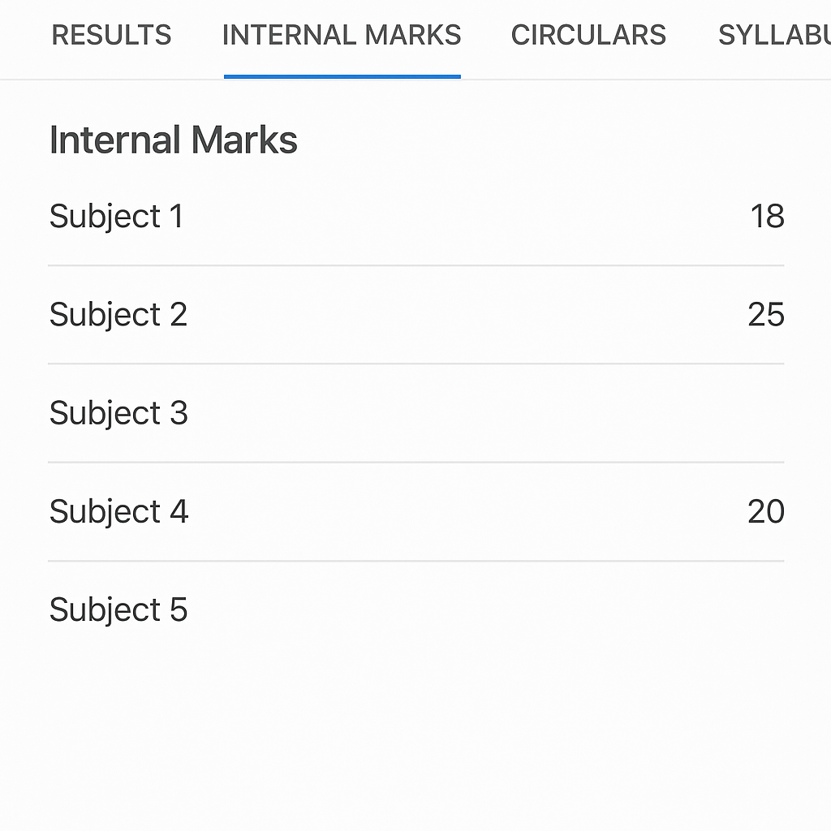

--------------------------------------------------------------------------------------

**Defect ID :** BUG-STUCOR-002

**Title :** App crashes on no internet during result

access

**Description :** App crashes if user taps Results with no

internet

**Steps to Reproduce :** Disable internet → Tap Results tab

**Expected Result :** Show 'No internet' message

**Actual Result :** App crashes

**Severity :** High

**Priority :** High

**Reported By :** Varalakshmi

**Date Reported :** 18-July-2025

**Status :** Open

**Proof (Defect Location) :** Results tab → Offline state

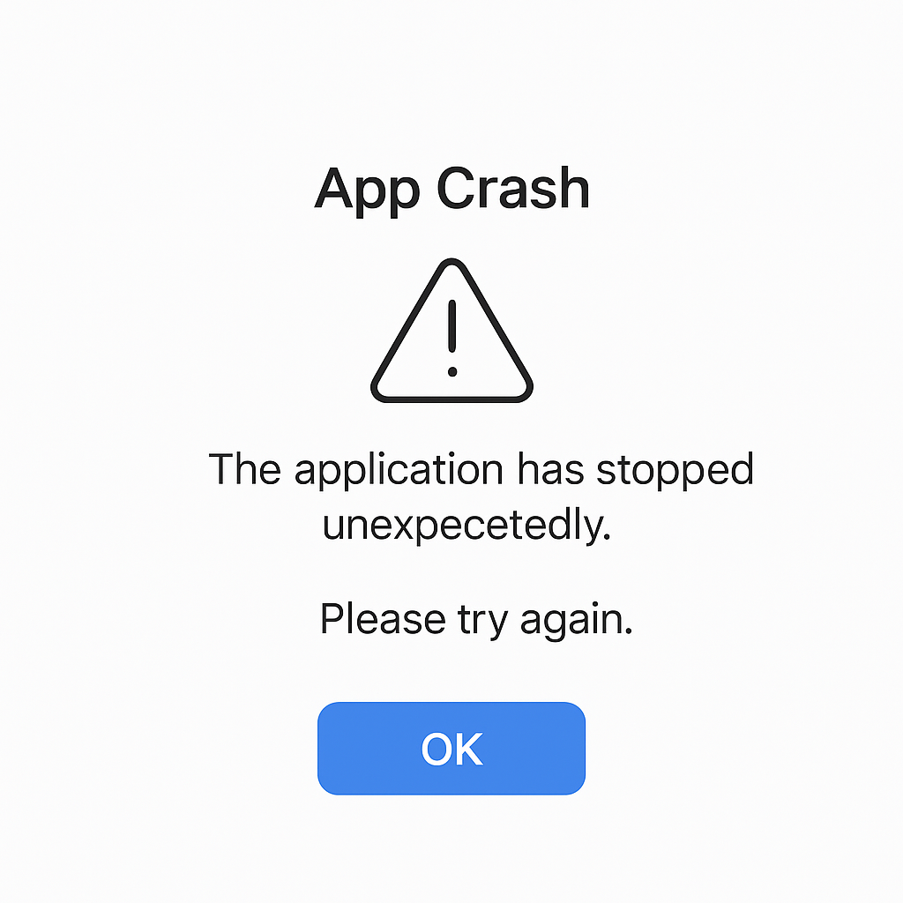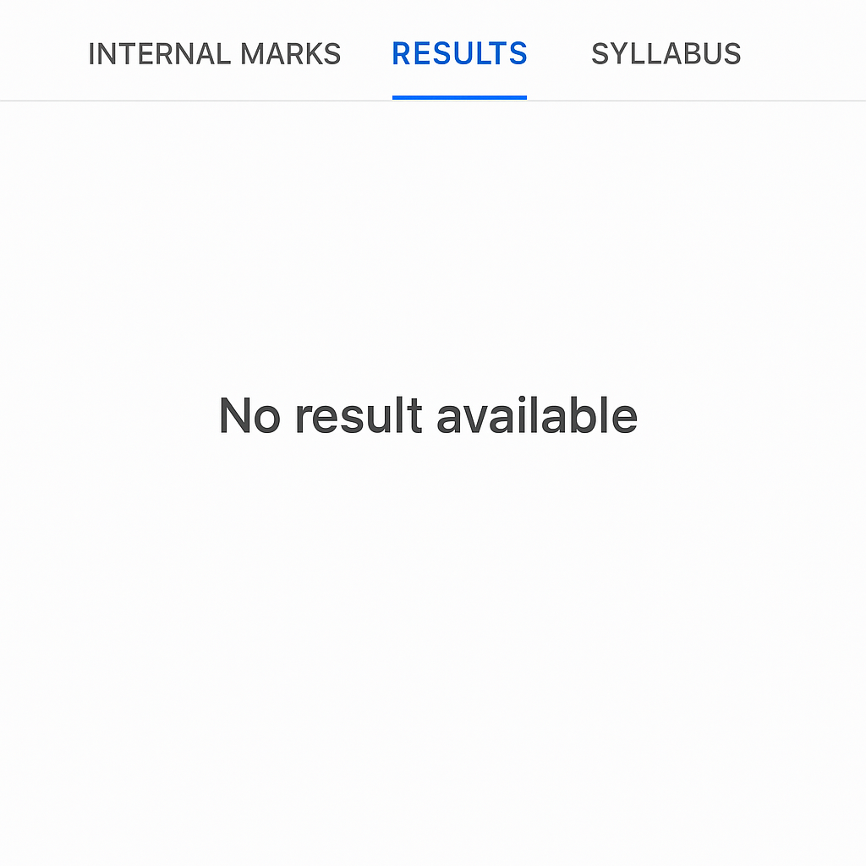

--------------------------------------------------------------------------------------

**Defect ID :** BUG-STUCOR-003

**Title :** UI layout broken on small devices

**Description :** UI elements overlap on smaller screen phones.

**Steps to Reproduce :** Open app on small device

**Expected Result :** Proper alignment

**Actual Result :** Text overlaps buttons

**Severity :** Medium

**Priority :** Medium

**Reported By :** Varalakshmi

**Date Reported :** 18-July-2025

**Status :** Open

**Proof (Defect Location) :** Home page → UI layout



